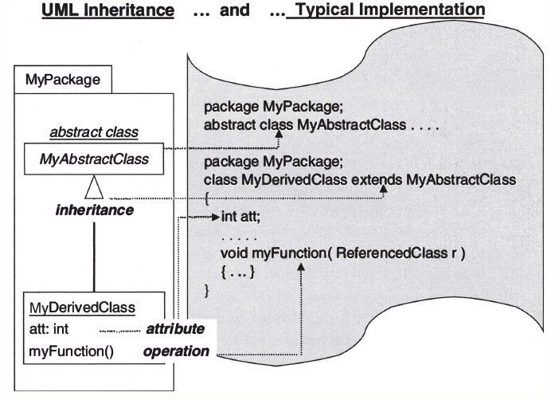  Figure 2.1 Inheritance (Generalization) | 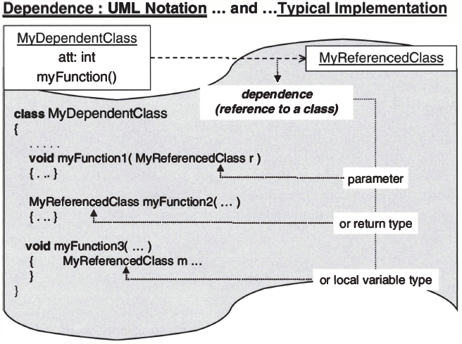  Figure 2.3 Java implementation of dependence (Dependency)
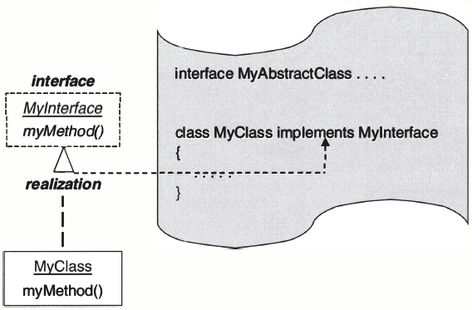  Figure 2.2 Interfaces (Implementation or Realization) | 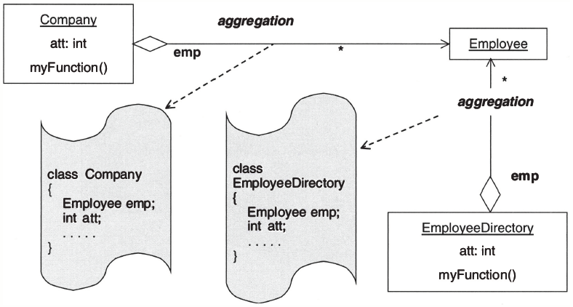  Figure 2.4 UML representation of aggregation

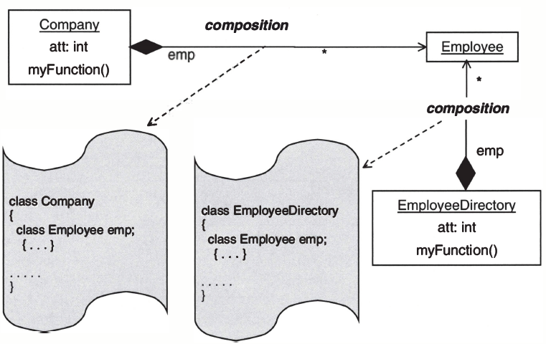
Figure 2.5 UML representation of composition (strong aggregation)
Tutorial 2
Abstract Factory GoF Definition: Provides an interface for creating families of related or dependent objects without specifying their concrete classes.
Abstract Factory Computer World Example
ADO.NET has already implemented similar concepts to establish a connection to a database.
Factory Method GoF Definition: Define an interface for creating an object, but let subclasses decide which class to instantiate. The factory method lets a class defer instantiation to subclasses.
Factory Method Computer World Example
In a Windows application, we may have different database users (e.g., one user uses Oracle and one may use Sql Server). Now whenever we need to insert data in our database we need to create either an SqlConnection or an OracleConnection first; only then we can proceed. If we put them into simple if-else, we need to repeat lots of codes and it doesn’t look good. We can use the factory pattern to solve these types of problems.
The basic structure is defined with an abstract class; our subclasses will be derived from this class. The subclasses will take the responsibility of the instantiation process.

Section I: AbstractFactory DP
- In File Explorer, navigate to your folder called “F:\YourName”.
- In Windows operating system, press “Windows + R” key.
- At ‘Open’ text field, type cmd to open command prompt.
- At the command prompt, type “F:”. Next, type “cd YourName”.
- At the F:\YourName> prompt, type “javac –version” to test your java compiler.
- In File Explorer, create subfolders of F:\YourName\02abstractfactory.
- Create MyAbstractFactoryPattern.java as a main class. Create AbstractFactoryPattern.java with the following code
public class AbstractFactoryPattern {
public static void main(String [] arguments){
System.out.println("Example for the AbstractFactory pattern");
System.out.println();
System.out.println(" Notice that you can");
System.out.println(" use the Address and PhoneNumber classes when writing");
System.out.println(" almost all of the code. This allows you to write a very");
System.out.println(" generic framework, and plug in Concrete Factories");
System.out.println(" and Products to specialize the behavior of your code)");
System.out.println();
System.out.println("Creating U.S. Address and Phone Number:");
AddressFactoryInterface addressFactory = new USAddressFactoryImpl();
AddressAbstractClass address = addressFactory.createAddress();
PhoneNumberAbstractClass phone = addressFactory.createPhoneNumber();
address.setStreet("142 Lois Lane");
address.setCity("Metropolis");
address.setRegion("WY");
address.setPostalCode("54321");
phone.setPhoneNumber("7039214722");
System.out.println("U.S. address:");
System.out.println(address.getFullAddress());
System.out.println("U.S. phone number:");
System.out.println(phone.getPhoneNumber());
System.out.println();
System.out.println();
System.out.println("Creating French Address and Phone Number:");
addressFactory = new FrenchAddressFactoryImpl();
address = addressFactory.createAddress();
phone = addressFactory.createPhoneNumber();
address.setStreet("21 Rue Victor Hugo");
address.setCity("Courbevoie");
address.setPostalCode("40792");
phone.setPhoneNumber("011324290");
System.out.println("French address:");
System.out.println(address.getFullAddress());
System.out.println("French phone number:");
System.out.println(phone.getPhoneNumber());
}
}
- Create AddressFactoryInterface.java with the following code
interface AddressFactoryInterface {
public AddressAbstractClass createAddress();
public PhoneNumberAbstractClass createPhoneNumber();
}
- Create USAddressFactoryImpl.java with the following code
class USAddressFactoryImpl implements AddressFactoryInterface{
public AddressAbstractClass createAddress(){
return new USAddress();
}
public PhoneNumberAbstractClass createPhoneNumber(){
return new USPhoneNumber();
}
}
- Create FrenchAddressFactoryImpl.java with the following code
class FrenchAddressFactoryImpl implements AddressFactoryInterface {
public AddressAbstractClass createAddress(){
return new FrenchAddress();
}
public PhoneNumberAbstractClass createPhoneNumber(){
return new FrenchPhoneNumber();
}
}
- Create AddressAbstractClass.java with the following code
abstract class AddressAbstractClass{
private String street;
private String city;
private String region;
private String postalCode;
public static final String EOL_STRING =
System.getProperty("line.separator");
public static final String SPACE = " ";
public String getStreet(){ return street; }
public String getCity(){ return city; }
public String getPostalCode(){ return postalCode; }
public String getRegion(){ return region; }
// Abstract method
public abstract String getCountry();
public String getFullAddress(){
return street + EOL_STRING +
city + SPACE + postalCode + EOL_STRING;
}
public void setStreet(String newStreet){ street = newStreet; }
public void setCity(String newCity){ city = newCity; }
public void setRegion(String newRegion){ region = newRegion; }
public void setPostalCode(String newPostalCode){ postalCode = newPostalCode; }
}
- Create PhoneNumberAbstractClass.java with the following code
abstract class PhoneNumberAbstractClass{
private String phoneNumber;
// Abstract method
public abstract String getCountryCode();
public String getPhoneNumber(){ return phoneNumber; }
public void setPhoneNumber(String newNumber){
try{
Long.parseLong(newNumber);
phoneNumber = newNumber;
} catch (NumberFormatException exc){
}
}
}
- Create USAddress.java with the following code
class USAddress extends AddressAbstractClass{
private static final String COUNTRY = "UNITED STATES";
private static final String COMMA = ",";
// Concrete method
public String getCountry(){ return COUNTRY; }
public String getFullAddress(){
return getStreet() + EOL_STRING +
getCity() + COMMA + SPACE + getRegion() +
SPACE + getPostalCode() + EOL_STRING +
COUNTRY + EOL_STRING;
}
}
- Create FrenchAddress.java with the following code
class FrenchAddress extends AddressAbstractClass {
private static final String COUNTRY = "FRANCE";
// Concrete method
public String getCountry(){ return COUNTRY; }
public String getFullAddress(){
return getStreet() + EOL_STRING +
getPostalCode() + SPACE + getCity() +
EOL_STRING + COUNTRY + EOL_STRING;
}
}
- Create USPhoneNumber.java with the following code
class USPhoneNumber extends PhoneNumberAbstractClass{
private static final String COUNTRY_CODE = "01";
private static final int NUMBER_LENGTH = 10;
// Concrete method
public String getCountryCode(){ return COUNTRY_CODE; }
public void setPhoneNumber(String newNumber){
if (newNumber.length() == NUMBER_LENGTH){
super.setPhoneNumber(newNumber);
}
}
}
- Create FrenchPhoneNumber.java with the following code
class FrenchPhoneNumber extends PhoneNumberAbstractClass{
private static final String COUNTRY_CODE = "33";
private static final int NUMBER_LENGTH = 9;
// Concrete method
public String getCountryCode(){ return COUNTRY_CODE; }
public void setPhoneNumber(String newNumber){
if (newNumber.length() == NUMBER_LENGTH){
super.setPhoneNumber(newNumber);
}
}
}
- At the command prompt, type “cd 02abstractfactory”.
- Compile with “javac *.java” and run the project “java AbstractFactoryPattern”.
In the output window you will see the following
Example for the AbstractFactory pattern
Notice that you can use the Address and PhoneNumber classes when writing
almost all of the code. This allows you to write a very generic framework, and plug in Concrete Factories and Products to specialize the behavior of your code)
Creating U.S. Address and Phone Number:
U.S. address:
142 Lois Lane
Metropolis, WY 54321
UNITED STATES

U.S. phone number:
7039214722

Creating French Address and Phone Number:
French address:
21 Rue Victor Hugo
40792 Courbevoie
FRANCE

French phone number:
011324290

- Exercise: Draw the Class Diagram for Tut2-Section I to show the relationship(s) between these classes, plus the attributes and methods of AddressFactoryInterface, FrenchAddressFactoryImpl, and USAddressFactoryImpl.
Sample solution:
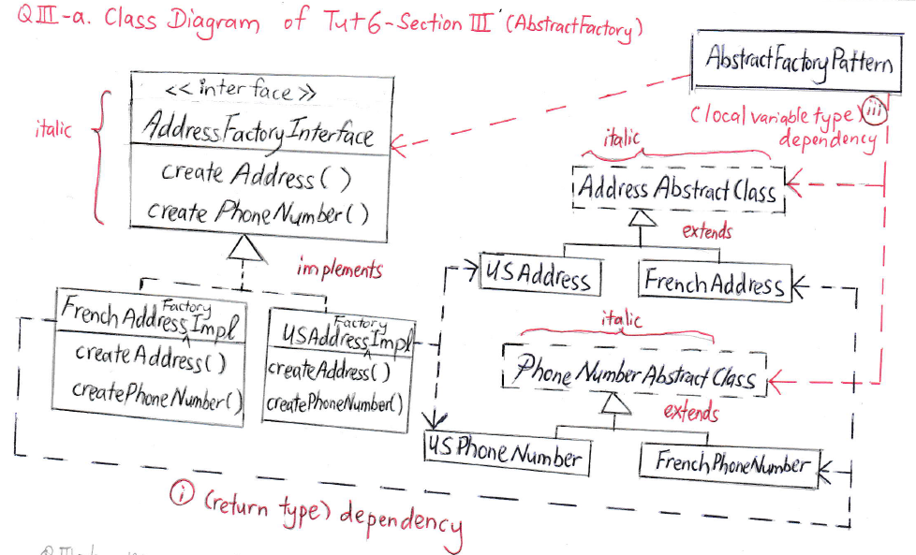
- Write the table for the mapping of AbstractFactory DP to the Section I.
Sample Solution: Mapping of Abstract Factory DP to Section I example
 | Name in DP | Actual Name
1. | AbstractFactory | AddressFactoryInterface
 | createProductA() | createAddress()
 | createProductB() | createPhoneNumber()
2. | ConcreteFactory1 | FrenchAddressFactoryImp, implements AbstractFactory (AddressFactoryInterface)
 | ConcreteFactory2 | USAddressFactoryImp, implements AbstractFactory (AddressFactoryInterface)
3. | AbstractProductA | AddressAbstractClass
 | ProductA2, ProductA1 | USAddress, FrenchAddress
4. | AbstractProductB | PhoneNumberAbstractClass
 | ProductB2, ProductB1 | USPhoneNumber, FrenchPhoneNumber
5. | Client | AbstractFactoryPattern

Section II: Factory Method pattern
- Refer to the steps above if necessary.
- In File Explorer, create subfolders of F:\YourName\02factory.
- Create FactoryMethodPattern.java as a main class.
- Modify FactoryMethodPattern.java to the following:
public class FactoryMethodPattern {
public static void main(String [] arguments){
System.out.println("Example for the FactoryMethod pattern - Creating a GUI editor for the Contact\n");
System.out.println("The GUI defined in the EditorGui class is a truly generic editor.");
System.out.println("It accepts an argument of type ItemEditor, and delegates");
System.out.println(" all editing tasks to its ItemEditorInterface and the associated GUI.");
System.out.println(" The getEditor() Factory Method is used to obtain the ItemEditor");
System.out.println(" for the example.");
System.out.println();
System.out.println("Notice that the editor in the top portion of the GUI is,");
System.out.println(" in fact, returned by the ItemEditor belonging to the");
System.out.println(" ContactEditableImpl class, and has appropriate fields for that class.\n");
// Create ContactEditableImpl object
System.out.println("Creating a Contact object.\n");
ContactEditableImpl someone = new ContactEditableImpl();
EditorGui editorGui = new EditorGui(someone.getEditor());
editorGui.createGui();
}
}
- Create ContactEditableImpl.java with the following code.
import java.awt.GridLayout;
import java.io.Serializable;
import javax.swing.JComponent;
import javax.swing.JLabel;
import javax.swing.JPanel;
import javax.swing.JTextField;
class ContactEditableImpl implements EditableInterface, Serializable {
private String name;
private String relationship;
// Factory method
public ItemEditorInterface getEditor() {
return new ContactEditorItemEditorImpl();
}
private class ContactEditorItemEditorImpl implements ItemEditorInterface, Serializable {
private transient JPanel panel;
private transient JTextField nameField;
private transient JTextField relationField;
public JComponent getGUI() {
if (panel == null) {
panel = new JPanel();
nameField = new JTextField(name);
relationField = new JTextField(relationship);
panel.setLayout(new GridLayout(2,2));
panel.add(new JLabel("Name:"));
panel.add(nameField);
panel.add(new JLabel("Relationship:"));
panel.add(relationField);
} else {
nameField.setText(name);
relationField.setText(relationship);
}
return panel;
}
public void commitChanges() {
if (panel != null) {
name = nameField.getText();
relationship = relationField.getText();
}
}
public String toString(){
return "\nContact:\n" +
" Name: " + name + "\n" +
" Relationship: " + relationship;
}
}
}
- Create EditableInterface.java with the following code:
interface EditableInterface {
public ItemEditorInterface getEditor();
}
- Create ItemEditorInterface.java with the following code:
import javax.swing.JComponent;
interface ItemEditorInterface {
public JComponent getGUI();
public void commitChanges();
}
- Write EditorGui.java with the following code:
import java.awt.Container;
import java.awt.event.ActionEvent;
import java.awt.event.ActionListener;
import java.awt.event.WindowAdapter;
import java.awt.event.WindowEvent;
import javax.swing.BoxLayout;
import javax.swing.JButton;
import javax.swing.JFrame;
import javax.swing.JPanel;
import javax.swing.JTextArea;
class EditorGui implements ActionListener{
private JFrame mainFrame;
private JTextArea display;
private JButton update, exit;
private JPanel controlPanel, displayPanel, editorPanel;
// ItemEditorInterface field
private ItemEditorInterface editor;
public EditorGui(ItemEditorInterface edit){
editor = edit;
}
public void createGui(){
mainFrame = new JFrame("Factory Pattern Example");
Container content = mainFrame.getContentPane();
content.setLayout(new BoxLayout(content, BoxLayout.Y_AXIS));
editorPanel = new JPanel();
editorPanel.add(editor.getGUI());
content.add(editorPanel);
displayPanel = new JPanel();
display = new JTextArea(10, 40);
display.setEditable(false);
displayPanel.add(display);
content.add(displayPanel);
controlPanel = new JPanel();
update = new JButton("Update Item");
exit = new JButton("Exit");
controlPanel.add(update);
controlPanel.add(exit);
content.add(controlPanel);
update.addActionListener(this);
exit.addActionListener(this);
mainFrame.addWindowListener(new WindowCloseManager());
mainFrame.pack();
mainFrame.setVisible(true);
}
public void actionPerformed(ActionEvent evt){
Object originator = evt.getSource();
if (originator == update){
updateItem();
} else if (originator == exit){
exitApplication();
}
}
private class WindowCloseManager extends WindowAdapter{
public void windowClosing(WindowEvent evt){
exitApplication();
}
}
private void updateItem(){
editor.commitChanges();
display.setText(editor.toString());
}
private void exitApplication(){
System.exit(0);
}
}
- At the command prompt, type “cd 02factory”.
- Compile with “javac *.java” and run the project “java FactoryMethodPattern”.

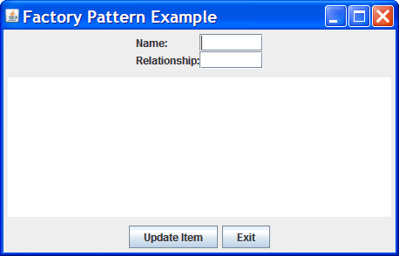
- In output window, you will see the following:
Example for the FactoryMethod pattern - Creating a GUI editor for the Contact
The GUI defined in the EditorGui class is a truly generic editor.
It accepts an argument of type ItemEditor, and delegates all editing tasks to its ItemEditorInterface and the associated GUI.
The getEditor() Factory Method is used to obtain the ItemEditor for the example.
Notice that the editor in the top portion of the GUI is, in fact, returned by the ItemEditor belonging to the ContactEditableImpl class, and has appropriate fields for that class.
Creating a Contact object.

QII-a. Draw the Class Diagram for Section II, which consists of ItemEditorInterface, ContactEditorItemEditor, {EditableInterface and ContactEditableImpl} with their getEditor() method.
QII-b. Write the table for the mapping of Factory Method DP to the Section II.

QII-b Sample Solution: Mapping of Factory Method DP to Tut2-Section II example
 | Name in DP | Actual Name
1. | Creator | EditableInterface
2. | ConcreteCreator | ContactEditableImp, a subclass of Creator
 | factoryMethod( ) | getEditor( )
3. | Product | ItemEditorInterface
4. | ConcreteProduct | ConcreteEditorItemEditorImpl, a subclass of Product, which is often anonymous

QII-b Sample Solution: Class Diagram for Tut2-Section II example mapped from Factory Method DP

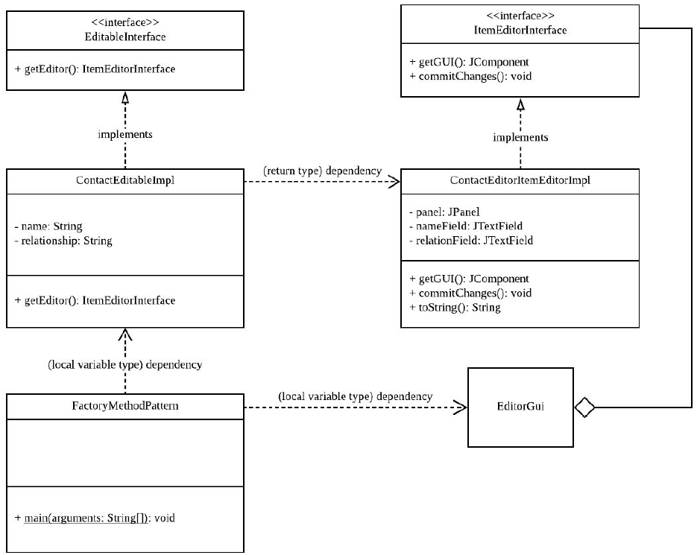
editor

Have fun!

